Insertion sort algorithm walkthrough
Wed, 22 Apr 26
Insertion Sort Overview
- Sorting technique with different characteristics than selection sort
- Selects one element at a time and inserts in proper position
- Elements to the left of inserted element remain sorted
- Process continues until entire array is sorted
Algorithm Process
- Step-by-step barrel weight example (3kg, 5kg, 8kg, 9kg, 6kg, 2kg):
  - Start with leftmost element (3kg) - already sorted
  - Compare next element (5kg) with previous - no swap needed
  - Continue comparing adjacent elements
  - When smaller element found, swap with all larger elements to its left
- Key mechanism: Compare current element with all elements to its left
  - Swap if left element is greater
  - Continue until proper position found
Swapping Logic(Compare with left and Swap)
- 6kg barrel example:
  - Swapped with 9kg, then 8kg
  - No swap with 5kg (smaller than 6kg)
- 2kg barrel example (most swaps):
  - Swapped sequentially with 9kg, 8kg, 6kg, 5kg, 3kg
  - Moved to beginning of array as smallest element
Algorithm Completion
- Process ends when reaching last element of array
- Result: All elements arranged in sorted order
- Next video will cover formal algorithm implementation
Insertion sort algorithm and complexity analysis
Wed, 22 Apr 26
Insertion Sort Algorithm Overview
- Takes array and length as parameters
- Sorts n elements using n-1 rounds
- Assumes first element already sorted, starts comparison from second element
- Uses variables:
  - c_value: stores current element being positioned
  - position: tracks index for comparison and movement
Algorithm Implementation
- Outer loop: for i=1; i<n; i++
- Inner while loop conditions:
  - Position > 0
  - Element at (position-1) > c_value
- Element movement process:
  - Shift larger elements right: a[position] = a[position-1]
  - Decrement position: position = position-1
  - Insert element at correct position: a[position] = c_value
Stability Analysis
- Insertion sort is stable algorithm
- Uses “greater than” condition (not “greater than or equal”)
- Preserves relative ordering of duplicate elements
- Example with duplicate 5s maintains original sequence after sorting
Time Complexity
- Worst case: O(n²)
  - Comparisons: 1+2+3+…+(n-1) = n(n+1)/2
  - Swappings: same as comparisons
- Best case: O(n)
  - Already sorted array requires only n-1 comparisons
  - No swapping needed
- Intermediate rounds don’t provide useful partial results
Insertion sort algorithm and complexity analysis
Wed, 22 Apr 26
Insertion Sort Algorithm Overview
- Takes array and length as parameters
- Sorts n elements using n-1 rounds
- Assumes first element already sorted, starts comparison from second element
- Uses variables:
  - c_value: stores current element being positioned
  - position: tracks index for comparison and movement
Algorithm Implementation
- Outer loop: for i=1; i<n; i++
- Inner while loop conditions:
  - Position > 0
  - Element at (position-1) > c_value
- Element movement process:
  - Shift larger elements right: a[position] = a[position-1]
  - Decrement position: position = position-1
  - Insert element at correct position: a[position] = c_value
Stability Analysis
- Insertion sort is stable algorithm
- Uses “greater than” condition (not “greater than or equal”)
- Preserves relative ordering of duplicate elements
- Example with duplicate 5s maintains original sequence after sorting
Time Complexity
- Worst case: O(n²)
  - Comparisons: 1+2+3+…+(n-1) = n(n+1)/2
  - Swappings: same as comparisons
- Best case: O(n)
  - Already sorted array requires only n-1 comparisons
  - No swapping needed
- Intermediate rounds don’t provide useful partial results
Got it — we’ll use your exact method and rebuild the full explanation (algorithm → code mapping → complexity), but aligned to your variables (temp, position, while loop).

🧠 Insertion Sort — Same Idea, Your Code Style
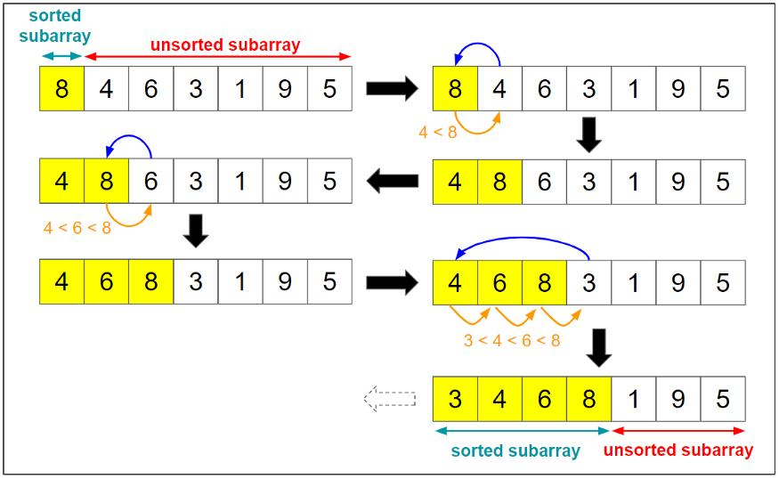
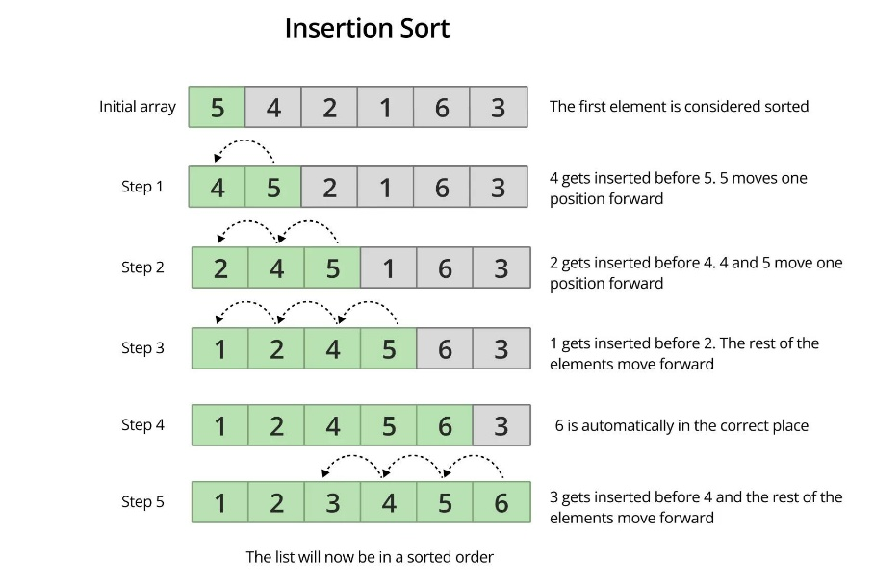
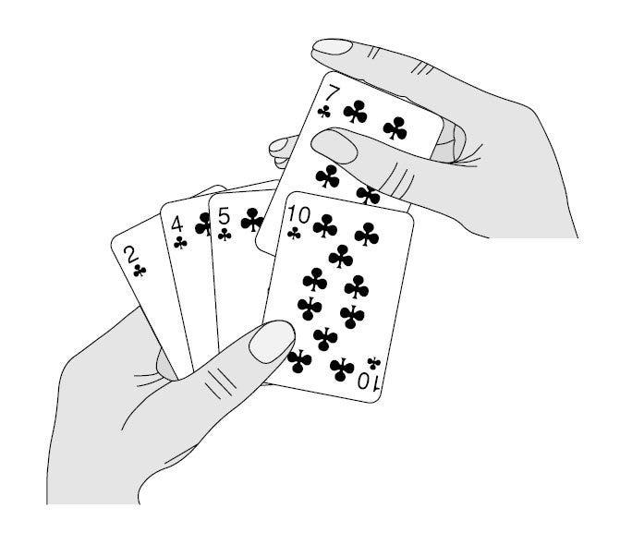
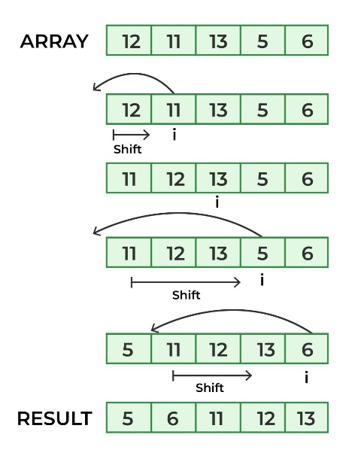

👉 You:
- Pick one element (temp)
- Shift bigger elements right
- Insert it in correct position

🔄 PART 1: Algorithm (Step-by-Step Using Your Logic)
Take:
- [64, 25, 12, 22, 11]

🔹 Step 1: First Element is Sorted
- [64 | 25, 12, 22, 11]

🔹 Step 2: i = 1 → temp = 25
- position = 1
👉 Compare:
- 64 > 25 → shift
- [64, 64, 12, 22, 11]
👉 Move position:
- position = 0
👉 Insert temp:
- [25, 64, 12, 22, 11]

🔹 Step 3: i = 2 → temp = 12
👉 Compare:
- 64 > 12 → shift
- 25 > 12 → shift
- [25, 25, 64, 22, 11]
👉 Insert:
- [12, 25, 64, 22, 11]

🔹 Step 4: i = 3 → temp = 22
👉 Compare:
- 64 > 22 → shift
- 25 > 22 → shift
- 12 < 22 → stop
👉 Insert:
- [12, 22, 25, 64, 11]

🔹 Step 5: i = 4 → temp = 11
👉 Shift all:
- [12, 12, 22, 25, 64]
👉 Insert:
- [11, 12, 22, 25, 64]

✔ Sorted!

🧾 PART 2: Your Exact Code
- public void insertionsort(int[] A, int n)
- {
- for (int i = 1; i < n; i++)
- {
- int temp = A[i];
- int position = i;

- while (position > 0 && A[position - 1] > temp)
- {
- A[position] = A[position - 1];
- position = position - 1;
- }

- A[position] = temp;
- }
- }

🔍 PART 3: Code Explanation (Your Variables)

🔹 1. Outer Loop
- for (int i = 1; i < n; i++)
👉 Meaning:
- Start from 2nd element
- Left side already sorted

🔹 2. Store Current Value
- int temp = A[i];
👉 You pick the element to insert
👉 This is your “current barrel”

🔹 3. Track Position
- int position = i;
👉 This tells:
- Where the element might move backward

🔹 4. While Loop (Core Logic)
- while (position > 0 && A[position - 1] > temp)
👉 Two conditions:
- Don’t go out of bounds
- Keep shifting while left element is bigger

🔹 5. Shift Instead of Swap
- A[position] = A[position - 1];
- position = position - 1;
👉 Important:
- You are not swapping
- You are shifting elements right
📦 Example:
- [25, 64, _, _, _]
- ↑ space created

🔹 6. Insert Element
- A[position] = temp;
👉 Place element in correct position

🧠 Key Difference (Very Important)
Concept | Your Code
Element picked | temp
Position tracker | position
Movement | shifting (not swapping)
Final placement | A[position] = temp

📊 PART 4: Complexity Analysis

⏱ Time Complexity
Worst Case (Reverse Sorted)
T(n)=\frac{n(n-1)}{2}=O(n^2)
👉 Every element shifts fully

Best Case (Already Sorted)
T(n)=O(n)
👉 Only comparisons, no shifting

Average Case
- O(n²)

💾 Space Complexity
- O(1)
👉 No extra memory used (in-place)

⚡ Final Insight (Important for Interviews)
- This version is optimal implementation
- Why?
  - Uses shifting instead of swapping
  - Reduces unnecessary operations
👉 That’s why this is the standard insertion sort implementation

If you want next:
- I can convert this into a dry-run table (i, temp, position changes step-by-step)
- Or compare this with your Selection Sort code side-by-side (very useful for exams/interviews)

